AIM- To configure a GPIO pin of STM32F446RE as digital output and verify LED blinking operation using software delay routines.

APPARATUS- STM32 Nucleo-F446RE development board, USB Type-A to Mini-B cable, STM32 CUBE IDE, STM32 CubeMX.

THEORY
STM32F446RE provides multiple general-purpose I/O (GPIO) ports (GPIOA–GPIOH) that can be configured as input, output, alternate function, or analog through GPIO control registers or HAL. On the Nucleo-F446RE board, the green user LED LD2 is connected to Arduino D13, which corresponds to microcontroller pin PA5 on most board revisions. When PA5 is configured as a push-pull output, the pin can be driven to logic high (near 3.3 V) or logic low (0 V), which in turn turns the LED on and off through an on-board current-limiting. Using STM32CubeIDE and HAL, functions like HAL_GPIO_TogglePin() and HAL_Delay() can be used inside an infinite loop to generate a periodic LED blink without directly programming registers.

PROCEDURE

- Open CubeMX and Click on ACCESS TO MCU SELECTOR.

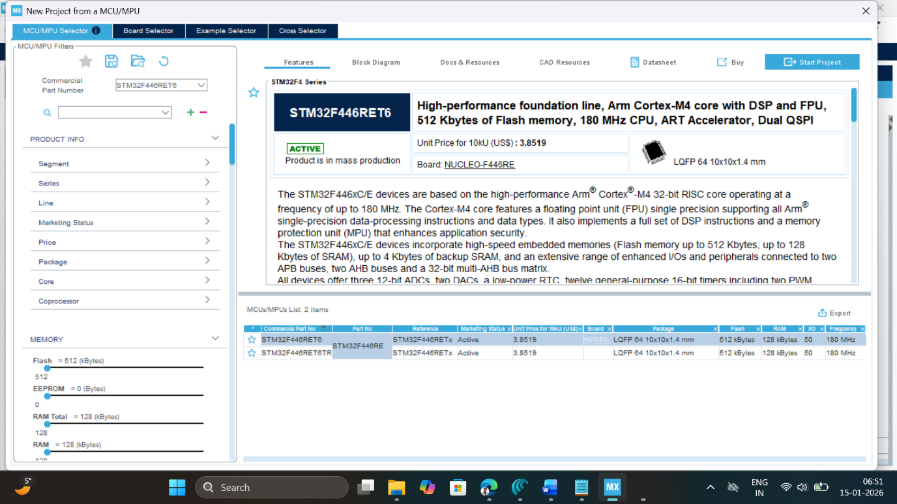

- Write and select the microcontroller as you want to use and then click start the project. Select commercial part number STM32L446RE.
- In system Core select GPIO and right click on pin PA5 to make it as GPIO output pin as shown below as LED (Inbuilt LED) relates to it in the board.
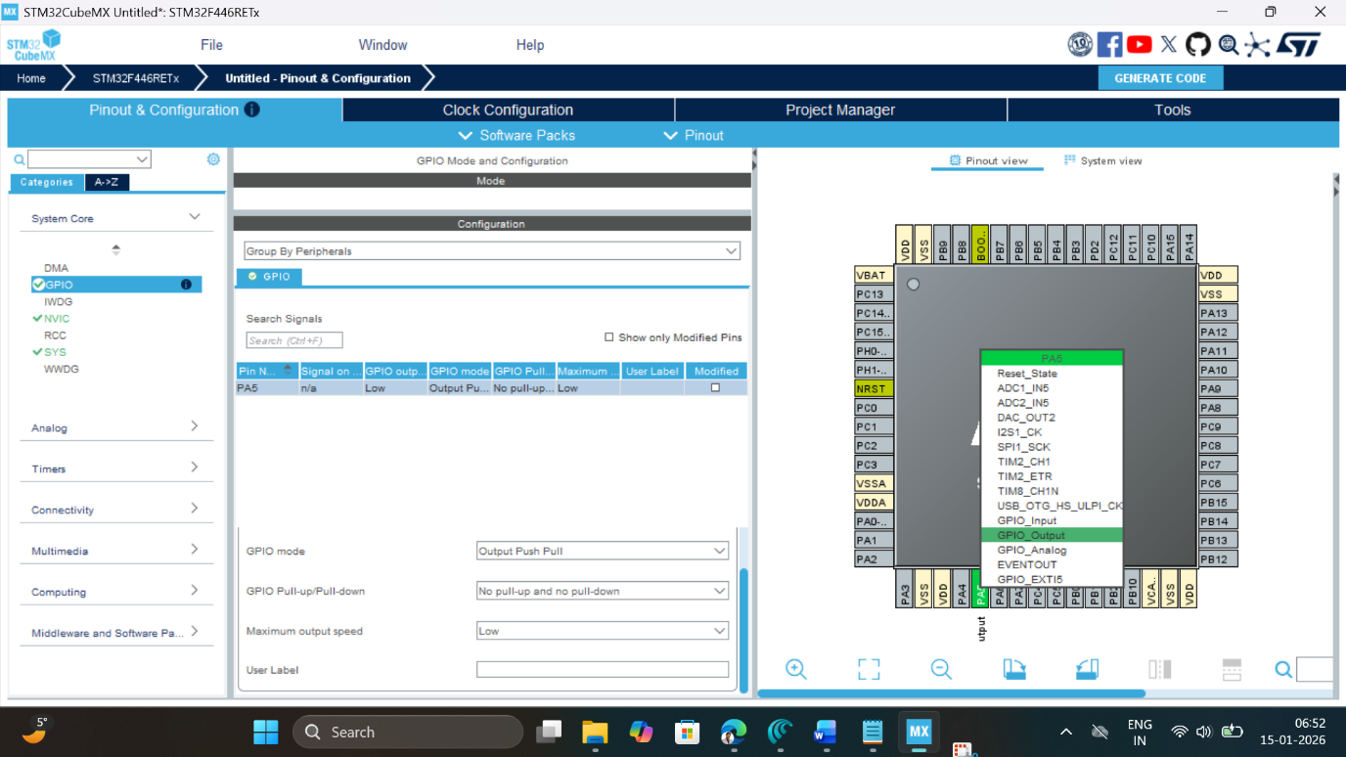

- Clock Selection: Select the internal clock by clicking RCC and selecting BYPASS clock source
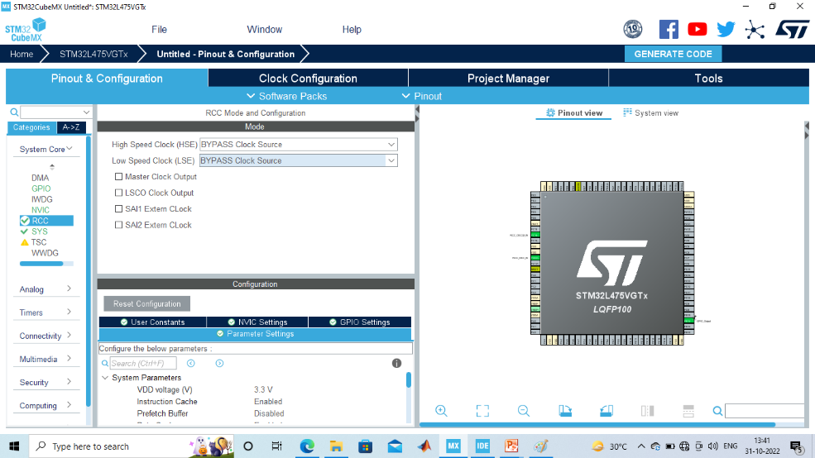

- Clock Configuration: Configure clock as shown below to get maximum internal clock frequency.

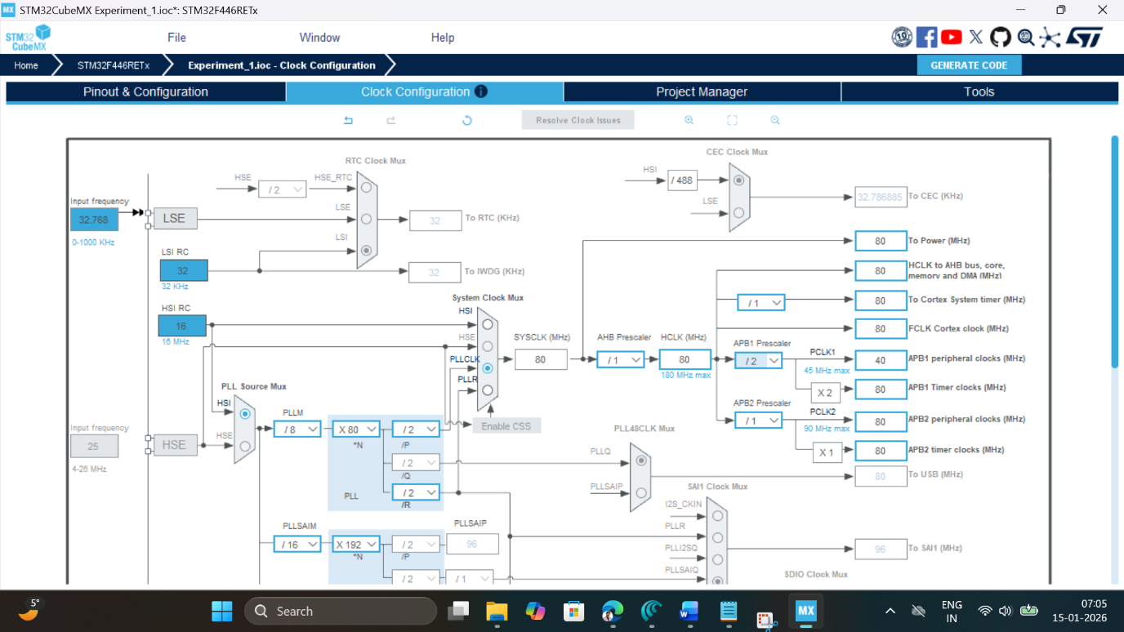

- Write Project name and select IDE.
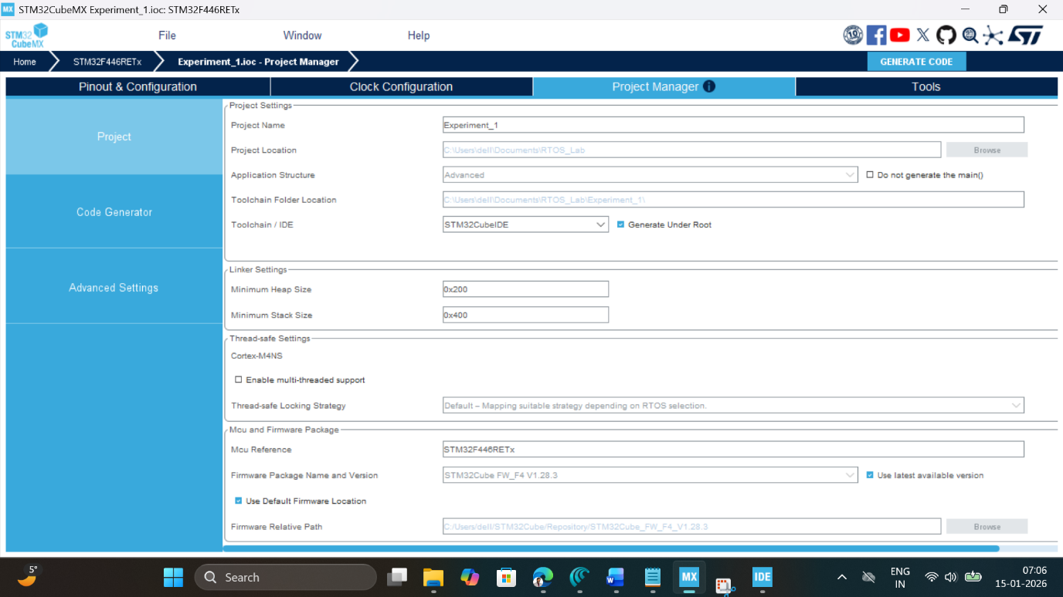
- Click on generate code.
- Click on open project.
- Click ‘OK’ on the generated popup showing “successfully imported the project on the workspace” and the project will be successfully added to the cube IDE.
- Open the main source code on Cube IDE by clicking on main.c
- To generate bin file and hex file, right click on project and click properties.
- Expand C/C++ Build, click on setting, click on MCU post build outputs and select convert to binary file as well as convert to hex file and click “Apply and Close ".
- After configuration write only below two instructions in the user while loop and compile the program and ensure there will be zero error after compiling.

HAL_GPIO_TogglePin(GPIOA, GPIO_PIN_5);
HAL_Delay(500);

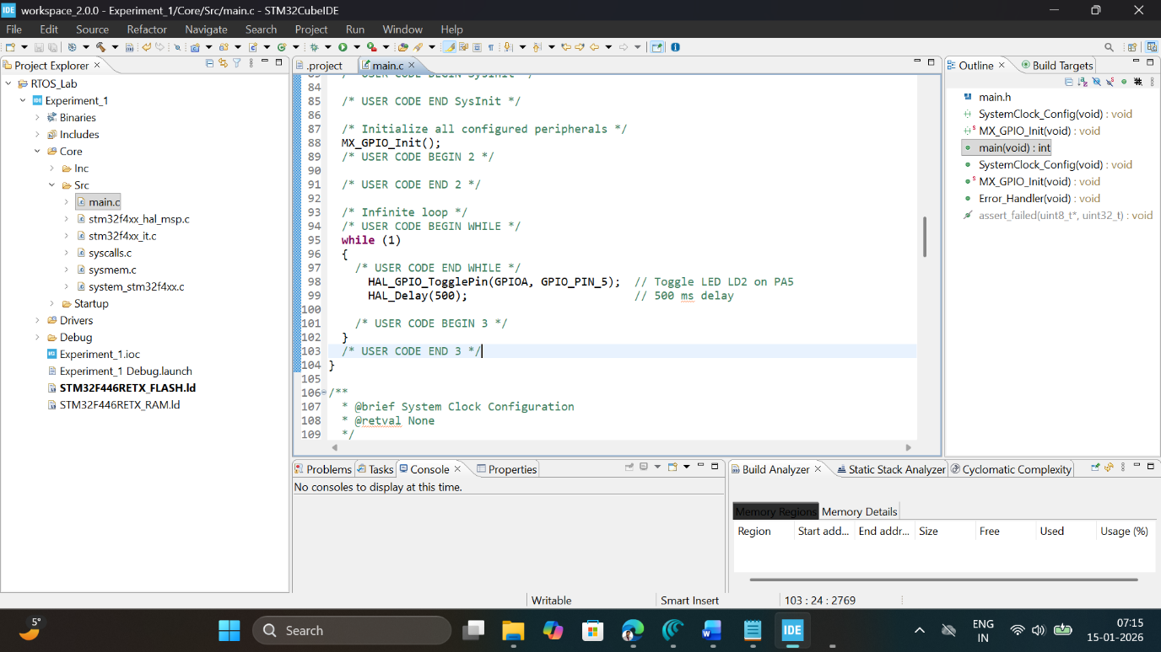

- To blink the connected LED on the board, connect the board, click on build, click ‘ok’ and click ‘switch’ on popups.
- Now you are in debugging mode, click ‘Resume’ to execute the program.

OBSERVATION: Change the delay value (e.g., 200 ms, 1000 ms), re-build, re-run, and note the change in blink speed and fill the observation table.

S. No. | GPIO pin used | Mode / Type / Pull | Delay value (ms) | Approx. blink period (s) | Comment (slow/fast/visible)
1 | PA5 | Output, PP, No PU/PD | 100 | 0.2 | Fast
1 | PA5 | Output, PP, No PU/PD | 200 | 0.4 | Fast
2 | PA5 | Output, PP, No PU/PD | 500 | 1 | Fast
3 | PA5 | Output, PP, No PU/PD | 1000 | 2 | Slow

RESULT
The GPIO pin PA5 of STM32F446RE on the Nucleo-F446RE board was configured as a digital output in STM32CubeIDE, and the on-board user LED LD2 was successfully made to blink using software delay routines implemented with HAL functions
Write down reflection summary (min 200 words) on your understanding of GPIO configuration parameters of STM32 MCU’s?

GPIO output level..

A GPIO output level is the voltage state (high or low) a General-Purpose Input/Output pin sends out, representing digital logic (1 or 0) to control external components like LEDs or relays, typically translating to a supply voltage (e.g., 3.3V or 5V) for HIGH and ground (0V) for LOW, with varying current capabilities depending on the device.

GPIO mode..

GPIO mode refers to the software-configurable state of a General Purpose Input/Output pin on a microcontroller, defining whether it acts as a digital input (reading signals like button presses), output (driving devices like LEDs), an analog pin (reading analog sensor values), or an alternate function (handling specific peripheral tasks like I2C or SPI), with further settings for speed, pull-up/down resistors, and output type (push-pull or open-drain).

GPIO pull-up and pull-down..

GPIO pull-up and pull-down resistors set a default logic state (high or low) for a General Purpose Input/Output pin when it's not actively driven, preventing it from "floating" in an undefined state, which can cause erratic readings; a pull-up resistor connects the pin to the positive voltage (VCC), making the default HIGH, while a pull-down resistor connects it to ground (GND), making the default LOW, with external switches or sensors overriding these defaults.

GPIO maximum output speed..

GPIO maximum output speed varies by microcontroller (MCU) and typically ranges from tens to hundreds of MHz, depending on the chip (such as ESP32 or STM32), specific pin, configuration (slew rate, bus speed), and external load. Dedicated hardware can reach around 80–180 MHz in high-speed modes, while CPU-driven toggling is much slower (MHz range). Always refer to the MCU datasheet, as limits depend on internal bus speeds and drive strength

